**Attendance system using MYSQL with Raspberry pi and RFID-RC522:**

In this project we are taking data from RFID reader which is connected to Node MCU V3 and saving it to PHPMYADMIN database running on Raspberry pi.

**Software Used:**

* Raspbian OS
* Arduino IDE
* My SQL Database

**Hardware Used:**

* Raspberry pi
* Node MCU V3
* RFID Reader with Tag
* Jumper Wire

**Raspberry Pi 3 pin block diagram:**

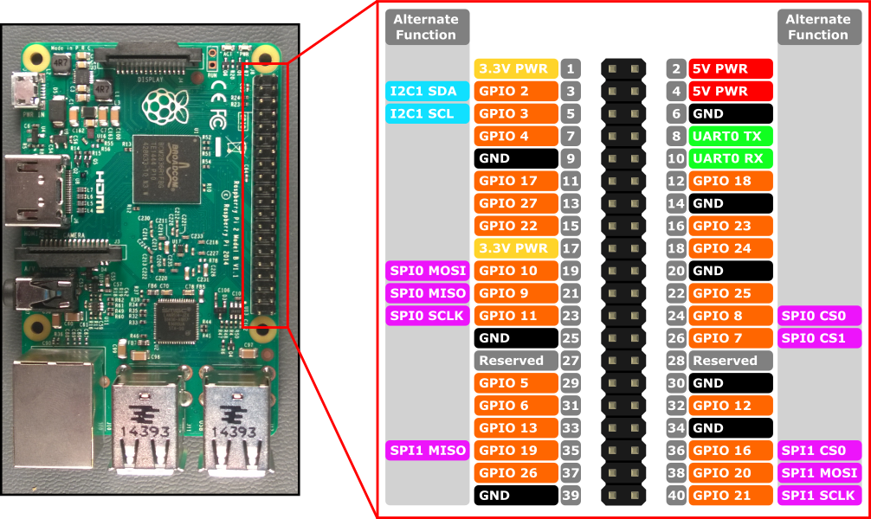

**Brief Description of Raspberry Pi**:

* This is the latest version of raspberry pi. In this we have inbuilt Bluetooth and wi-fi, unlike previously we have to use Wi-Fi dongle in one of its usb port. There are total 40 pins in RPI3.  Of the 40 pins, 26 are GPIO pins and the others are power or ground pins (plus two ID EEPROM pins.)
* There are 4 USB Port and 1 Ethernet slot, one HDMI port, 1 audio output port and 1 micro usb port and also many other things you can see the diagram on right side. And also we have one micro sd card slot wherein we have to installed the recommended Operating system on micro sd card.
* There are two ways to interact with your raspberry pi. Either you can interact directly through HDMI port by connecting HDMI to VGA cable, and keyboard and mouse or else you can interact from any system through SSH(Secure Shell). (For example in windows you can interact from putty ssh.)

**Node MCU V3** :

NodeMCU is an open source IOT platform. It includes firmware which runs on the ESP8266 Wi- Fi SoC from hardware which is based on the ESP-12 module. The term "NodeMCU" by default refers to the firmware rather than the dev kits.

**Circuit Diagram:**

